**IELTS Writing Quiz**

**Writing Task 1**

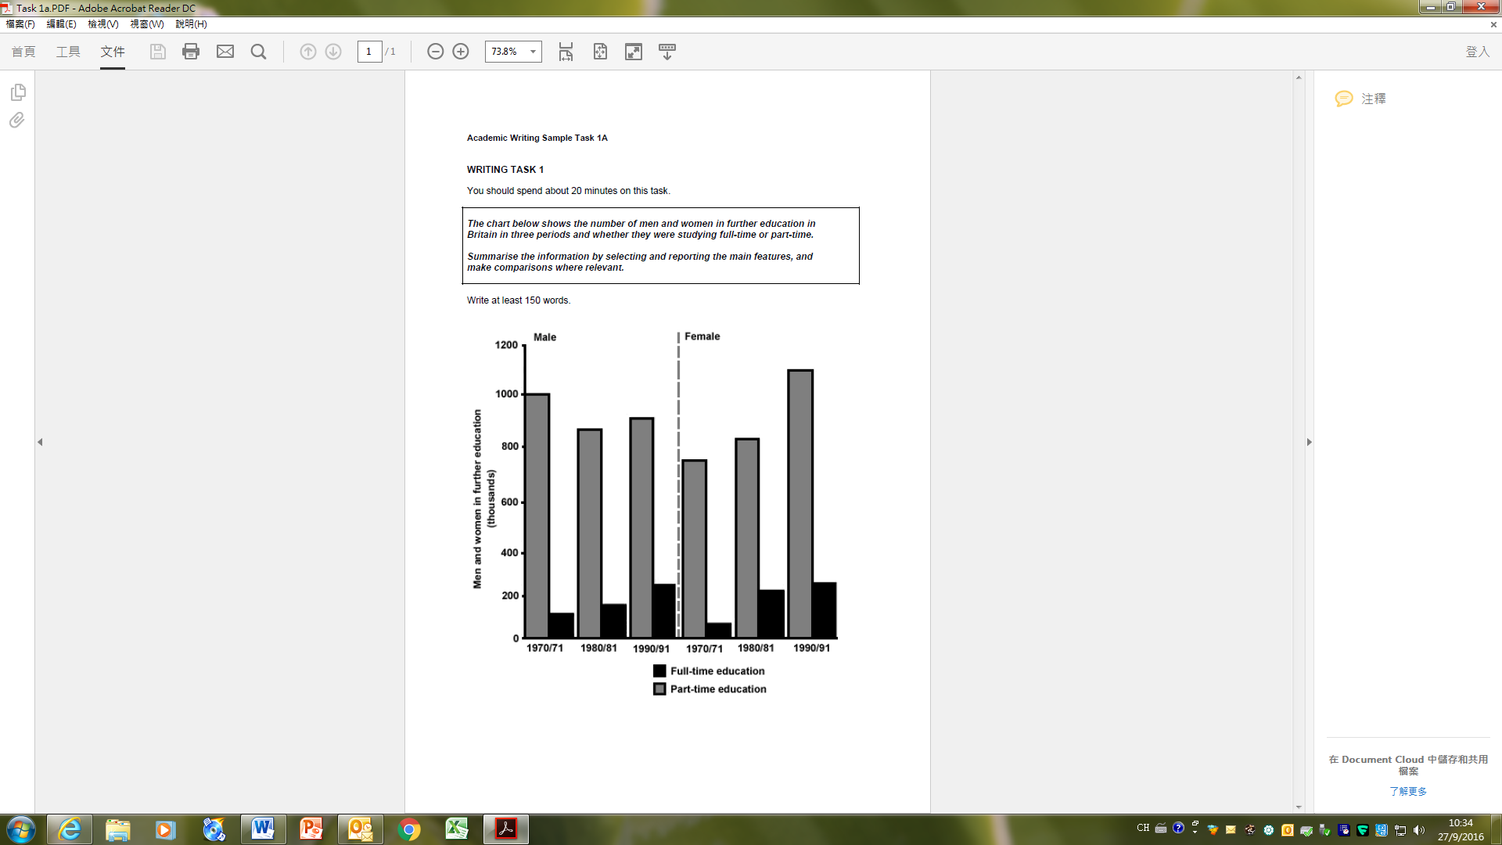

**Writing Task 2**

**You should spend 40 minutes on this task.**

|  |
| --- |
| Every year, international newspapers rank world cities according to their qualities. Such qualities may include affordable medical care, good education, a fair legal system, etc. List three qualities which you believe are most important, and give reasons for your choice. |

**Writing Consultation Question Answer**

**Jiawei Wang, Angold**

**Writing task1:**

**The bar graph shows the state of British further education during three different periods with the number of men and women respectively. In general, ~~we can see that the~~ educated people increased, with the proportion of women showing the most significant rise. Fine overview here.**

**According to the chart, between 1970 and 1990, the population of full-time educated women increased by nearly a third, from 760,000 to 1100,000. But the population of full-time educated men fluctuates around 950,000 during these years. Furthermore, During the periods from 1970 to 1971, significantly fewer women received further-education than man; but in 1990, there are more women who spend(t) their life at further-education school – even much more than man.**

**Nice data description. Mind consistency and accuracy of your tense use.**

**One interesting observation is that the number of having part-time education women ~~has~~ nearly tripled from 1970 to 1990. ~~I guess one of the reasons is that as the development of manufacturing, more and more women are liberated from the work of housewives because of the emergence of the house helper such as washing machine, which makes them have more time focus on their own life.~~**

**(177 words)**

**6.5-/9**

**7-/9 (if no opinionated expressions included) Nice try. Data presentation is relevant and on-point. Clear organization. Task purpose achieved. Mind your tense us, word choice and minor grammar lapses. Remember no opinionated expressions/ reasons/ assumptions in Task 1. Keep working.**

**Writing task 2:**

**It is widely accepted that~~,~~ the most important part of a city is the people who live in there. And I believe that as a member of the city, while I am studying, struggling and living. There are 3 qualities of a city that I concerned – Ancient Culture, Reasonable Pressure and Environment.**

**As we define “culture” as shared beliefs, values, attitudes and behaviors, it stands to reason then that a person’s city of origin impacts their culture. ~~I think~~ the culture of a city stands for the habits and traditions left by the residents who lived here in the past, the historic buildings like Universities or some famous sites. that makes the residents have their unique lifestyle. Since one’s city of origin is only one aspect of our collective culture, we all adopt elements from other cultures on a daily basis, unconsciously or according to our preference. To my mind, this is what makes the world such an interesting place. Illustration is fine here.**

**Despite a continuing improvement in standard of living, I still believe that young people suffer more stress than old generations. ~~I think~~ the main reason is that sometimes people confused “Challenge” and “Pressure”. Excessive stress will only make people anxious, like the rocketing housing prices and the endless overtime work. Only reasonable pressure can be called “Challenge”. And supervise them is what the government need to do. Need more elaboration on more concrete suggestions on how to improve standard of living in a city and any ‘stress relief’ measures.**

**A polluted urban environment affects not only people’s mood, but also their health. In most cases, preventing illness is a more efficient and less-cost way than treating them. Clean water, lush woods and blue sky… these can also prevent people from getting sick.**

**To sum up, my main idea of this essay is that~~:~~ the best city is the place people live with happiness and feel comfortable. Though everyone’s criteria are quite different, I believe that there will be some common grounds.**

**(308 words)**

**6.5/9 Nice try. Some ideas are sensible and organization is generally clear. Can provide some concrete examples for some illustration. Mind some grammar lapses too. Keep working.**